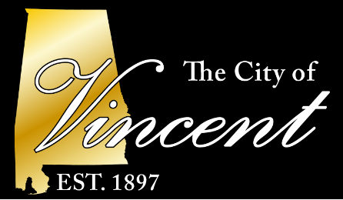
City Of Vincent
PO BOX 49
Vincent, AL 35178

Phone: 205-672-2261
Fax: 205-672-7662

Vincent's Christmas Parade
Event will be held Friday December 6th, 4-8 pm at City Hall
Setup will begin at 2pm. ALL VENDORS must be set up by 4 pm
Email application to: hthweatt@cityofvincental.com

Vendor Application Type Food/Food Truck____ Arts/Crafts/Business____ Other________________________
Last Name_________________________________ First Name__________________________________
Business Name________________________________________________________________________________________________
Address_____________________________________________________________________________________________________
Email______________________________________________ Contact Phone Number_______________________________
Description of Vendor Booth_____________________________________________________________________________________
________________________________________________________________________________________________________________________________________________________________________________________________________________________

GENERAL TERMS OF VENDOR PARTICIPATION AGREEMENT
1. Vendor shall be responsible for set-up and removal of their own equipment, fixtures, and other property. Electricity will NOT be provided.
2. Food vendors must list and sell only items listed on the application.
3. Vendor shall occupy only the assigned space which is 12 x 12.
4. Vendors should have adequate protection for inclement weather, the sun and heat. Vendors shall be prepared to continue vending from the allocated space in the event of rain. Bring appropriate coverage. If the weather becomes too inclement to operate vending booths, The City of Vincent will be responsible for making final determination of outdoor operations.
5. Vendor shall provide adequate personnel for the operating hours of the event.
6. Vendor may not sell or consume alcoholic beverages.
7. Vendor shall comply with all laws, ordinances, rules and regulations of any lawful authority, agency or government unity which apply to the use of its vending unit requirements, including without limitation, any applicable fire and building code of the City of Vincent, and health regulations of the Shelby County Health Department.
8. Vendor agrees to indemnify and hold harmless the City of Vincent, its officers, directors, representatives, employees, and agents for all penalties, fines, costs, expenses, damages, from the participating vendor’s failure to comply with such laws.
9. Vendor shall maintain allocated space and vending unit in a neat, safe, and orderly condition during the event.
10. Vendor shall furnish trash containers and bags and bag all garbage and trash on a regular basis during the event. At the conclusion, vendor must remove garbage, and equipment from the allocated vending space.
11. Vendor agrees that THE CITY OF VINCENT, its officers, directors, representatives, employees, and agents shall have no responsibility whatsoever for any loss or damage to vendor’s equipment, supplies, goods, or other property.
12. Vendor agrees to indemnify and hold harmless representatives, employees, and agents of the festival and/or the City of Vincent against all claims of any person whomsoever, from acts or omissions of the vendor, its representatives, employees, agents, patrons, or guests.

I have read the 'General Terms of Vendor Participation Agreement' and agree to abide by its rules and all terms and conditions set forth therein.

SIGNATURE:__________________________________________________________________________Date:___________________
Please keep a copy of this agreement for your record

